Formulärets överkant
FH -FINALHAIR orderform  Order #  RUSH (add USD 20/pc) |  | Name/address:  Telephone:  E-mail:
Quantity
Plastic template YesNo |  | IF NO TEMPLATE: base (+front ) Width: x Length: (inch or cm)  Your head shape, more: Round Oval  Front shape: A AA B BB C CC  Back shape: A AA B BB C CC

 | Front material  Front color tone: (not Swiss lace)  Front size: | Base material  Base color tone: (not Swiss lace)
 | Natural hairline: (graduated density) Comments, natural hairline:
Perimeter material: On its own On the base material
Perimeter color toner: Other:
Perimeter width: 2/4"(1.27cm) 3/4" (1.91 cm) 1" (2.54cm) Other:
Perimeter placement: Back Back/sides Entire perimeter Other:

 | Part material: Notes:

Hair type | Remy Indian hair (Fine/medium texture)  Chinese hair (semi thick texture) - good for Asian people Remy Chinese hair (thick texture) - good for Asian people  Synthetic hair Heat resistant Synth hair  Other:

Hair density standard: 1. Medium = 100% 2. Medium = 130% See hair density
1. Extra light: 40%, Light: 60%, Medium light: 80%, Medium: 100%, Medium heavy: 120%, Heavy: 140%
2. Extra light: 50%, Light: 80%, Medium light: 100%, Medium: 130, Medium heavy: 150%, Heavy: 180%
Other standard:

Hair direction | Left crown Center crown Right crown Left part Center part Right part Left break Right break Flat back Pomp, brush back Free style Other:
Bleached knots | Notes:
Bleached knots | Front Base (not injected systems) Notes:

 | FRONT | TOP | TEMPLES | SIDES | CROWN | BACK
Hair length
Hair density
Hair color
No red tone
High lights %
Grey %
Human
Wave/curl

No wave/curl 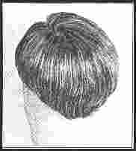 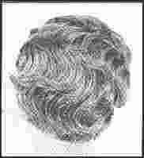 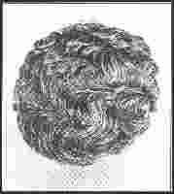 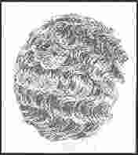 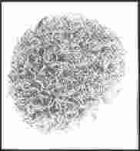 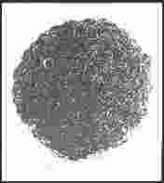
1. Straight 2. Body wave 3. Slight wave 4. Medium wave 5. Tight wave 6. Medium curl 7. Tight curl 8. Other
Or in cm:

Make your own system:
Tape/glue:
Payment options: Paypal (credit cards) Bank wire
Keep my template/hairsamples at the factory My template/hairsamples are stored at the factory
Send it from word. Or send as PDF file.
Formulärets nederkant

